
Assessment: Breathing Pattern Disorder

Patient Details Date of Assessment:………………….………..

Name: …………………………………………. Hospital Number: ……………………………….

History of Present Complaint
Jt Stiffness Breathlessness

Cough Sighing
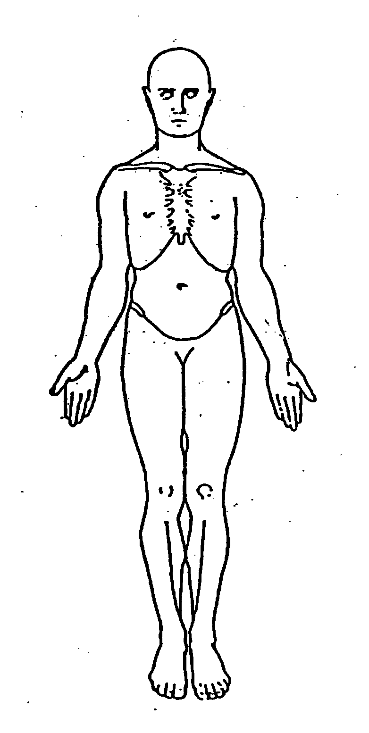
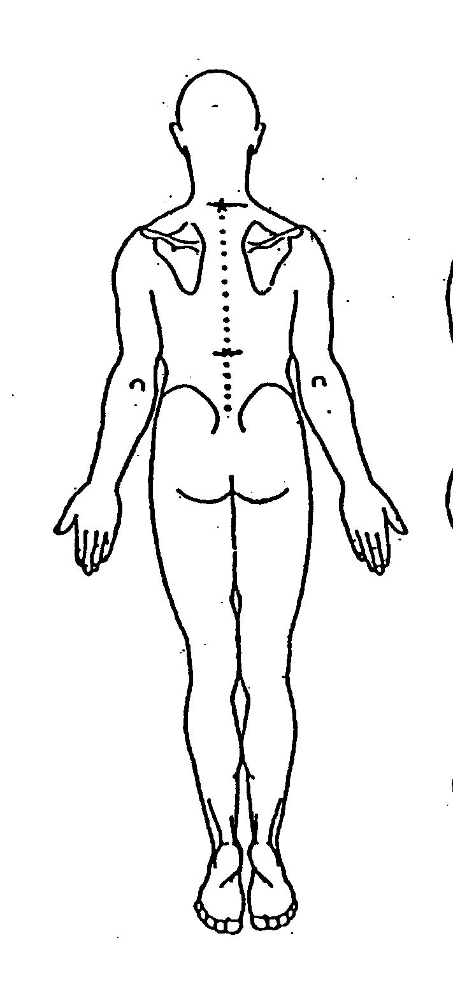

Dizziness Yawning

Unable to breathe deeply

Visual problems Fatigue

Tingling Palpitations

Muscular aches Chest pain

Anxiety Tension

Panic attacks Headaches

Throat/Gastric problems

Detached from reality

Poor concentration

Dizziness Hearing sensitivity

Other symptoms: .……….……………………………………………………………………………….

Frequency: …………………………………………………………………………………………………

Duration: ……………………………………………………………………………………………………

Onset:………………………………………………………………………………………………………

……………………………………………………………………………………………………………..

……………………………………………………………………………………………………………….

Past Medical History ……………………………………………………………………………………..

………………………………………………………………………………………………………………

……………………………………………………………………………………………………………….

Respiratory Disease………………………………………………………………………………………………………

………………………………………………………………………………………………………………

Investigations: Blood tests LFT’s ABGs

ECG Chest X-ray

Results if abnormal: ………………………………………………………………………………………..

………………………………………………………………………………………………………………

Current Medications …………………………………………………………………………………….

………………………………………………………………………………………………………………

………………………………………………………………………………………………………………

Previous Physio Treatment / Other Treatments …………………………………………………….

………………………………………………………………………………………………………………

Social History……………………..…………………………………………………………………..….

………………………………………………………………………………………………………………

Occupation: ………………………………………………………………………………………………..

Hobbies / Daily lifestyle: ………………………………………………………………………………….

……………………………………………………………………………………………………………..

………………………………………………………………………………………………………………

Sleep pattern: ………………………………………………………………………………………………

Diet: …………………………………………………………………………………………………………

Caffeine/alcohol………………………………………………………………………………………………

Exercise ability……………………………………………………………………………………………….

Physiotherapist name………………………………... Signature…………………………………

Patient Name: ………………………………… Hospital No: …………………………………….

Objective Assessment

General appearance / observation……………………………………………………………………..

………………………………………………………………………………………………………………

………………………………………………………………………………………………………………

Breath hold …Insp ……….………….Exp…………………………

Respiratory pattern:

Upper chest / diaphragm ………………………………………...………………………………………

Erratic / rhythmical …………………………………………………………………………………………..

Nose / mouth ……………………………Insp/Exp………………………………………………………..

Tidal Volumes ………………………………………………………………………………………………

Rate…………………………………………Noisy/Quiet……………………………………………………

Other………………………………………………………………………………………………………….

M/S Assessment

Posture …………Sitting…………………………Standing……………………………………………..

Thoracic ROM……Flex…………………Ext………………RR…………………LR………………….

Muscle length/trigger points - Scalenes………………………Pect Minor………………………………

Diaphragm………………………………………………………………………………………………….

Ribs – Rib spaces equal……………………………………………………………………………………

Anterior Rib Dysfunction……………………………Posterior Rib Dysfunction……………………….

Inspiratory Dysfunction ……………………………..Expiratory Dysfunction…………………………..

Other Assessment details………………………………………………………………………………….

……………………………………………………………………………………………………………….

………………………………………………………………………………………………………………

Physiotherapist Name…………………………….. Signature………………………………………...

Nijmegen Questionnaire

Patient’s Name ………………………………….. Hospital No. ……………………………………..

Date: ………………………………………………

 | Never  (0) | Rarely  (1) | Sometimes  (2) | Often  (3) | Very often  (4)
Chest pain
Feeling tense
Blurred vision
Dizzy spells
Feeling confused
Faster / deeper breathing
Short of breath
Tight feelings in chest
Bloated feeling in stomach
Tingling in fingers
Unable to breathe deeply
Stiff fingers / arms
Tight feelings around mouth
Cold hands / feet
Heart racing (palpitations)
Feelings of anxiety
Total Score

Signature: ……………………………………………

Date: …………………………………………. Name: ………………………………………………..

Name: Hospital No:

TREATMENT OBJECTIVES

No | Objective | GOAL | Achieved
1 | Explanation of condition / HVS and provide with information booklet. Reassurance and explanation that improvement can take time/effort.
2 | Breathing Retraining:  I) Breathing awareness  II) Practise breathing retraining:  - Diaphragm  - Deeper Basal  - Volume  - Rate  - Pattern  III) Positions:  - Lying  - sitting  - standing
3 | Teach Relaxation techniques:  - Demonstrate relaxation –awareness of tension  - Provide with information on methods of relaxation  III) Practise relaxation daily 15 – 20 mins
4 | I) Stress management strategies  - Lifestyle changes  II) NLP
5 | I) Advise on Regular Eating habits  ( e.g Avoid hypo/hyperglycaemia)  II) Reduce stimulants
6 | Advise on Sleep
7 | a) Breathing & Exercise  - basal expansion  b) Breathing & Talking  - Slow down  - Diaphragm control

